Voice Acting Information for :
Edwyn Tiong
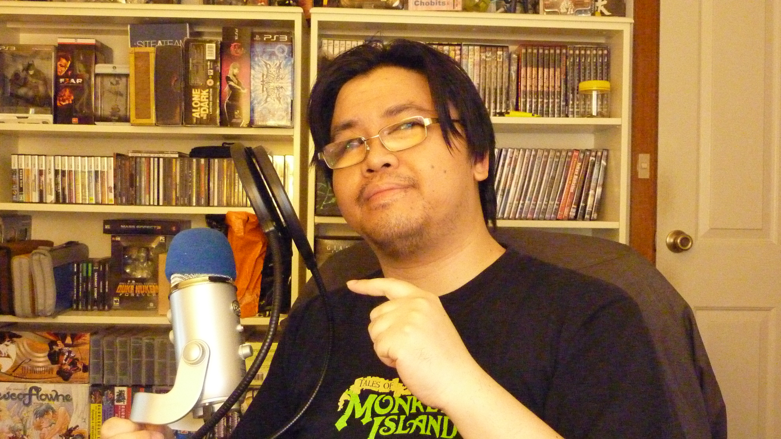
I'm an overweight Asian man with goldfish bowls for eyes and a Blue Yeti microphone and I'm not afraid to use one or the other to do my voice acting! Mostly the microphone, though.

E-mail : edwyn.tiong@internode.on.net
Website (if you have one): https://www.facebook.com/pages/Omahdon/221140257985203
Location : Adelaide, South Australia
Accents (you don’t have to put this): Unidentifiably American - perhaps New England?
Bio (use 3rd person cause it's all fancy): Edwyn first started voice acting for online projects in 1999 and hasn't looked back since. He has seen what was once a niche hobbyist pursuit grow into a burgeoning industry unto itself - and he likes it! Especially the monies. Monies are awesome. And honing one's acting craft and skill. But mostly monies.
You may have heard his voice in a variety of online productions including Xin, 8-Bit Theater Flash Adaptation, Megaman Zero: The Last Cataclysm, Super Freakin Parody Rangers, Drowtales animations, Sonic: Nazo Unleashed, Bad Atom, Smashtasm, Deus Ex: The Nameless Mod, Wonders of the Universe, Oddball, Ace Pilot, Guinea Something Good, Wing Commander Saga: The Darkest Dawn, The Journey Down: Chapter 1 and most infamously as Dan McNeely in the Trapped pentalogy of games. When he's not busy voice acting, he's busy producing (and voicing) works such as the Drowtales audiobooks, the VG Cats Adaptation With No Name series and the i fail game videogame commentary series.
He is currently finishing up principle recording on the iOS game Detective Grimoire: Secret of the Swamp and will be several character voices in Paradox Interactive's upcoming game Dungeonland and a voice in the Xbox Live Arcade game Dust: An Elysian Tail.
Feel free to Contact Edwyn regarding voice acting for your projects! Just don't forget your huge sacks of monies to pour on his person!

